Asia-China-Coin-Wang Mang 10,000-Mould

4.5cm. / 1.77 in., width, 14.2cm. / 5.59 in.

国宝金匮直 万,"GuoBaoJinKuiZhiWan"falchion-shape coin.国宝金匮直万,Very beautiful font on the body.It is the most high value coin in chinese coin history which could be used as 10.000 basic coins in that time It was made and used in the XinMang Time(7-23AD),Late HanDy Period.

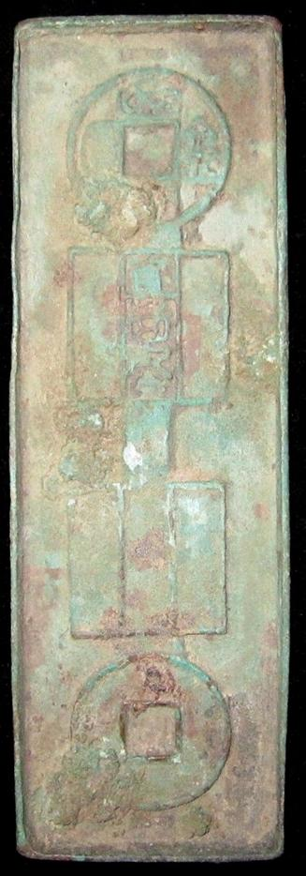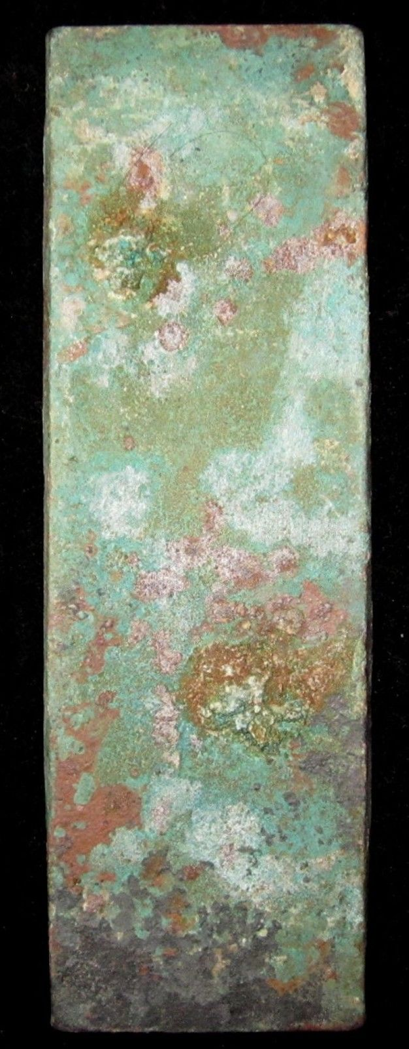

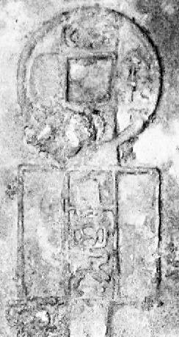 SHAPE \* MERGEFORMAT 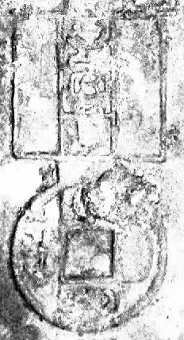

Order details Printer friendly page

Sold by

[bcculture](http://myworld.ebay.com/bcculture) ( [81](http://feedback.ebay.com/ws/eBayISAPI.dll?ViewFeedback&userid=bcculture)  )

+ Show additional actions

Delivery package 1 of 1

Estimated delivery Friday, Jan 17, 2014 - Wednesday, Feb 5, 2014

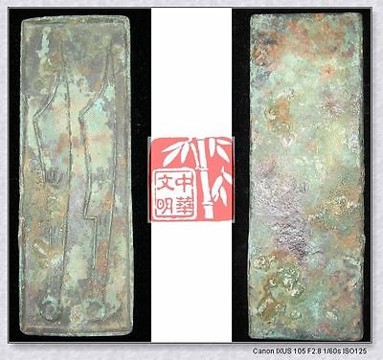

[WARRINGSTATESPERIOD YAN NATION MINT MONEY MODEL BRONZE FALCION COIN PATTERN针首刀6"](http://www.ebay.com/itm/251391538342)

Item price

$79.99

Quantity

1

Item number

251391538342

Shipping service

Economy Shipping from outside US

[Leave feedback](http://feedback.ebay.com/ws/eBayISAPI.dll?LeaveFeedbackShow&useridfrom=802-867&useridto=bcculture&item=251391538342&transactid=1360128554015) [Contact seller](http://contact.ebay.com/ws/eBayISAPI.dll?FindAnswers&frm=3998&iid=251391538342&redirect=0&requested=bcculture) [Return item](http://return.ebay.com/ws/eBayISAPI.dll?ResolveReturn&eventName=viewSelectedItem&TransactionId=1360128554015&ItemId=251391538342)

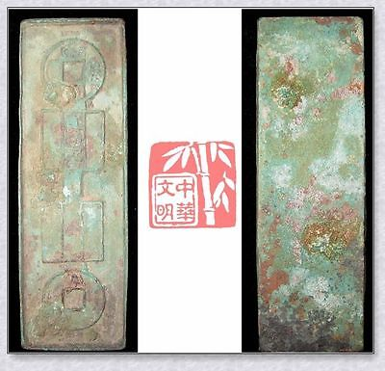

[VINTAGE HAN XINMANG TIME ￥10000 MONEY MODEL BRONZE FALCHION COIN PATTERN国宝金匮直万6"](http://www.ebay.com/itm/251396289678)

Item price

$69.99

Quantity

1

Item number

251396289678

Shipping service

Economy Shipping from outside US

[Leave feedback](http://feedback.ebay.com/ws/eBayISAPI.dll?LeaveFeedbackShow&useridfrom=802-867&useridto=bcculture&item=251396289678&transactid=1360163231015) [Contact seller](http://contact.ebay.com/ws/eBayISAPI.dll?FindAnswers&frm=3998&iid=251396289678&redirect=0&requested=bcculture) [Return item](http://return.ebay.com/ws/eBayISAPI.dll?ResolveReturn&eventName=viewSelectedItem&TransactionId=1360163231015&ItemId=251396289678)

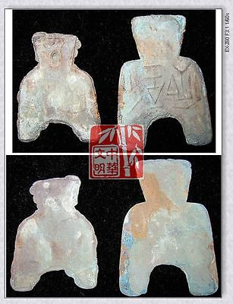

[WarringStatesPeriod WEI NATION CAPITAL MINT WEIGHT MONEY BRONZE SPADE COIN虞*釿SET](http://www.ebay.com/itm/251413448140)

Item price

$69.99

Quantity

1

Item number

251413448140

Shipping service

Economy Shipping from outside US

[Leave feedback](http://feedback.ebay.com/ws/eBayISAPI.dll?LeaveFeedbackShow&useridfrom=802-867&useridto=bcculture&item=251413448140&transactid=1360205391015) [Contact seller](http://contact.ebay.com/ws/eBayISAPI.dll?FindAnswers&frm=3998&iid=251413448140&redirect=0&requested=bcculture) [Return item](http://return.ebay.com/ws/eBayISAPI.dll?ResolveReturn&eventName=viewSelectedItem&TransactionId=1360205391015&ItemId=251413448140)

### Shipping address

Ralph J Coffman Jr  
149 Atlantic Ave   
Swampscott MA 01907-2427  
United States

Phone number  
781 584 7091

### Order total

Subtotal $219.97

Shipping $80.00

Discount -$15.00

#### Total

## $284.97

[View PayPal transaction](http://payments.ebay.com/ws1/eBayISAPI.dll?IntermediateResolutionInfo&itemid=0&transId=0&pn=UnifiedCheckoutSummaryRedirect2PP&qs=itemid%3D0%26transId%3D0%26buyerorseller%3D0%26)

### Order information

Order placed on  
Sunday, Dec 29, 2013

Having a problem with this purchase?  
[Resolve problem](http://res.ebay.com/ws/eBayISAPI.dll?ResolutionCenter)

Payment method   
PayPal

Payment date  
Sunday, Dec 29, 2013